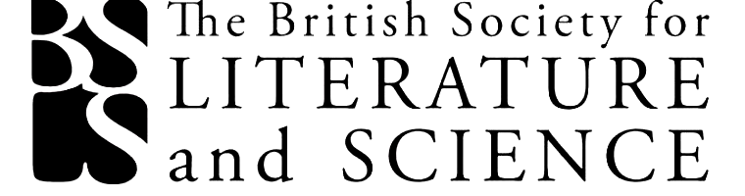


The British Society for
Literature and Science

21st Annual Conference

University of Strathclyde
Technology & Innovation Centre
9th – 11th April 2026

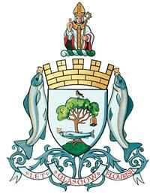
Thursday 9th April

10.00: Registration and refreshments (Level 3 Mezzanine)
NB. Luggage can be stored in the TIC cloakroom

10.00 – 11.30: PGR Training: Turning Your Research into Outreach (Auditorium B)

12.00: Lunch (Level 3 Centre)

12.45 - 13.00: Welcome (Auditorium B)

13.00 - 14.00: Plenary 1: Zoë Lehmann Imfeld (University of Bern), ‘Occupy Mars!: Discourses of Mars Colonisation’
Chair: Jordan Kistler

14.00-15.30: Parallel sessions 1

Panel 1.1: Health Communication (Room 1)
Chair: Jordan Kistler
- Rachel Cairns (University of Strathclyde), ‘Fategorisation: Constructing fat identity categories in healthcare, popular culture, and fiction’
- Phoebe O’Leary (University College Dublin), ‘Colin Murphy’s Miasma and the Dynamics of Public Understanding’
- Aline Ferreira (Universidade de Aveiro, Portugal), ‘Youthful Centenarians and Immortal Babies: Eve Smith’s The Cure (2025) and Kira Peikoff’s No Time to Die (2014)’

Panel 1.2: Caribbean Writing and the Blue Humanities (Auditorium B)

Chair: Emily Alder
- Elina Valovirta (University of Turku, Finland), ‘Escapes by Water: Materialist Caribbean Waterways and the Blue Humanities’
- June Douglas (St. George's University), ‘An exploration of environmental change portraying environmental degradation and offering insight into future challenges through the lens of Caribbean experiences’
- Antonia MacDonald (St. George's University), ‘Ecological Precarity and Poetic Form in Derek Walcott’s “The Sea at Dauphin”’

Panel 1.3: What, Why, How?: Ways of thinking with about culture and genomics (Room 2)

Chair: Martin Willis
- Lara Choksey (UCL): ‘Environments of blame and their dissonant oscillations’
- Jay Clayton (Vanderbilt University): 'Transdisciplinary Collaboration: Literature and Genomics'
- Jerome de Groot (University of Manchester): ‘Neanderthal Mud: Towards a Biomolecular Hamlet’

Panel 1.4: 19th-Century Popular Science (Room 3)

Chair Brycchan Carey
- Madeleine Chalmers (University of Glasgow), ‘Not Rocket Science: Making Space for All with Camille Flammarion’
- Gary Kelly (University of Alberta), ‘Science as Literature: Penny-Periodical Poetics for Mechanics’ Modernity’
- Bethany Dahlstrom (Independent Scholar), ‘After-Dinner Science: Parlour Microscopy and Victorian Bird Preservation’

Panel 1.5: Frankenstein’s Afterlives (Room 4)

Chair: Ángeles Jordán Soriano
- Jasmine Erdener and Şima İmşir (Koç University), ‘When the Monster Wants Love: AI and Affective Labour in Del Toro’s Frankenstein’
- Brianna Nicole Frentzko (University of York), ‘Mad Scientist for Sale: Commodifying the Pursuit of Knowledge in Margaret Atwood’s Oryx and Crake’
- Georgina Kosanovic (Regent High School, London), ‘Dangerous Doctors and Terrifying Technology: What GCSE Novels Say about Science’

Panel 1.6: Indian Fiction and the Body (Room 5)

Chair: John Holmes
- Sadaf Mehmood (Quaid-i-Azam University, Islamabad), ‘Biopolitics of Syphilis: Women, Contagion and Urdu Literary Imagination’
- Aysha Femin NK (Birla Institute of Technology and Science, Pilani), ‘The Affective Life of Smallpox in Select Twentieth-Century Malayalam Novels’

15.30 - 16.00: Refreshments

16.00 - 17.50: Parallel sessions 2

Panel 2.1: Interchanges: Science, Medicine, Politics, Poetry (Auditorium B)
Chair: Alice Jenkins
- Michael H. Whitworth (Merton College, Oxford), ‘Scientific Citations of Virginia Woolf’
- Brian Hurwitz (King's College London), ‘The Invention of "Medical Humanities"’
- Ángeles Jordán Soriano (University of Almería, Spain), ‘The Scientific Revolution as Fashion: Veronica Forrest-Thomson’s Poem “Epicurus” and the Spectacle of Modernity’
- Annabel Williams (University of St Andrews), ‘‘A flat earth view of the mind’: Cold War Pseudoscience and the Work of Arthur Koestler’

Panel 2.2: Empirical Methods in Literature and Science (Room 1)

Chair: Will Tattersdill
- Charlotte Stobart (University of Cambridge), ‘Technological Embodiment: Experiences of Calliper Usage Among British Polio Disabled Individuals, 1950-2025'

Panel 2.3: H. G. Wells, Evolution, and Deep Time (Room 2)

Chair: Emily Alder
- Lily Fell (University of Manchester), ‘Deep time in deep water: panic and marshland materiality in H. G. Wells’ The Croquet Player (1936)’
- Billie Gavurin (University of Birmingham), ‘Gothic Palaeoanthropologies at the Turn of the Century’
- Gemma Curto (University of Sheffield), ‘A “Tangled Skein”: Evolution, Chance, and Environmental Instability from Julian Huxley and the Wells (1929) to Rachel Carson (1962)’
- Claudia Sterbini (University of Edinburgh), ‘Sexology, Nonsexual Patients, Nonsexual Doctors: Threatening Failed Evolutions in The Island of Doctor Moreau’

Panel 2.4: Romanticisms (Room 3)

Chair: Sara Cole
- Sharon Ruston (Lancaster University), ‘Selected Poetry of Humphry Davy’
- Jude Mahmoud (University of Oxford), ‘Voids and Vacuities: Newtonian Critique in William Blake’s Fall’
- Paul Hamann-Rose (University of Passau), ‘Innovation in The Athenaeum: John Aikin’s Editorial Aesthetics of Poetry and Natural History’

Panel 2.5: Twenty-First Century Science Fiction

Chair: Emilie Walezak
- Megan Woodward (University of York), ‘Anthropocene sinthomosexuality in Ian McEwan's Solar’
- Nicole Brandstetter (University of Applied Sciences Munich, Germany), ‘Epistemological Failures in Contemporary Climate Fiction: Knowledge Without Transformation in Boyle, Flor, and Bjerg’
- Anton Kirchhofer (Oldenburg) and Anna Auguscik (Bremen), ‘Alien Expeditions? Practice, Calculation and the Expedition Narrative in Contemporary Speculative Fiction’
- Bidisha Nandi (University of Strathclyde), ‘Nature's In(ter)vention: Gothic Doubles and the Ecological Uncanny’

Panel 2.6: Literature and Science on Screen (Room 5)

Chair: Antonia MacDonald
- Laura Kremmel (Niagara University), ‘Showing Your Age: Medical Examination in Elder Horror’
- Zixin Yan (University of Leeds), ‘Listening, Silence, and Montage: Translating Mother–Daughter Interviews into Experimental Video Installation’
- Tom Hedley (Université libre de Bruxelles), ‘Hilbert’s Hotel Revisited: Turning Topologically with F.W. Murnau’s "Der letzte Mann" and Vicki Baum’s "Menschen im Hotel"’
- Peter Sands (University of York), ‘Bugonia and Paranoid Environmentalism’

18.30: Civic Reception, Glasgow City Chambers

Friday 10th April

9.00 Refreshments (Level 3 Centre)

9.30 – 11.00: Parallel sessions 3

Panel 3.1: Medico-Literary Hybridity in the Nineteenth Century (Room 1)
Chair: Brian Hurwitz
- Megan Coyer (University of Glasgow), ‘Private Practices: Medical Fiction and the Manuscript Medical Casebook’
- Eeva Savolainen (University of Stirling), ‘“Can I describe what I saw!”: Diagnostic Horror in “The Thunder-Struck—The Boxer”’
- Mila Daskalova (University of Glasgow), ‘From Case Notes to Memoirs: The Nineteenth-Century Alienist as a Biographer’

Panel 3.2: What Can Poetry Do? (Room 2)
Chair: John Holmes
- Amna Umer Cheema (University of the Punjab/University of Sheffield), ‘How does Elizabeth Bishop think Blue? A Hydrocene Reading of “The Map”’
- Emilie Walezak (Nantes Université), ‘Repurposing Natural History: Poetic Experiments vis-à-vis the Procedural Methods of Natural Sciences’
- Ralph O’Connor (University of Aberdeen), ‘Beyond the “Great Sea-Dragons”: Thomas Hawkins and the Miltonic Gothic

Panel 3.3: Religion and Science (Room 3)

Chair: Brycchan Carey
- Emilie Taylor-Pirie (University of Birmingham), ‘“Relenting God”: faith, science, and belief in turn-of-the-century medical poetry’
- Jenni Halpin (Savannah State University), ‘Letting Light Shine for Catholic Robots and Agnostic Scientists’
- Sofie Vandepitte (KU Leuven - Universiteit Gent), ‘The (Divine) Natural World in the Belgian Children’s Magazines Zonneland and Petits belges’

Panel 3.4: Memoirs/Memory (Room 4)

Chair: Jerome de Groot
- Caitlin Kawalek (University of Cambridge), ‘Wandering from the ‘Beaten Track’: Laetitia Pilkington, Aesthetic Error, and Predictive Processing’
- Harley Ryley (University of Sheffield), ‘The Memoirist's Guide to Memory Science: problematising memory concepts to unlock deeper autobiographical truths’
- Hyeonsu Kim (Chungbuk National University, Korea), ‘Beyond Resolution: Trauma as Disability in The Perks of Being a Wallflower’

Panel 3.5: Temporality (Auditorium B)

Chair: Prathiksha Betala
- Jaroslav Kušnír (University of Presov, Slovakia), ‘Science, Technology and Literature in Charles Yu´s How to Live Safely in a Science Fictional Universe’
- Piotr Czerwiński (Rzeszów University of Technology, Poland), ‘Exploring the Spatial and Temporal Dimensions of Consciousness in Samantha Harvey’s Orbital’
- Kate Foster (University of Reading), ‘“Time does not exist – we invented it. Time is what the clock says”: Clocks, Time Travel and Albert Einstein in Early-Twentieth Century Fiction’

Panel 3.6: What Does this Text Know? (Room 5)
Chair: Jim Scown
- Caspar Wort (Loughborough University), ‘Formulations: Scientific Verse as High-Context Poetics’
- Adele Guyton (UCLouvain), ‘What Science Fiction’s Plots Don’t Know About Scientific Methods’
- Alice Jenkins (University of Glasgow), ‘What does this poem know about maths, and when does it know it?’

11.00 - 11.30: Refreshments (Level 3 Centre)

11.30 – 13.00: Parallel sessions 4

Panel 4.1: Emerging Technologies: Artificial Women and Virtual Realities in Contemporary Science Fiction (Room 1)
Chair Rachel Cairns
- Eleanor McAdam (University of Liverpool), ‘Outsourcing Motherhood: Artificial Mothers in science fiction literature’
- Faye Lynch (University of Liverpool), ‘Artificial Girlfriends, Real Problems: AI Girlfriends and the Fictional Fembot in the 21st Century’
- Gabriel Burrow (Birkbeck), ‘Creating the Torment Nexus: Silicon Valley, Science Fiction, and the Metaverse’

Panel 4.2: Victorian Health (Room 2)

Chair: Felix Behler
- Anne-Marie Millim (University of Luxembourg), ‘“Pain comes without a voice” (Kempner): The Representation of Migraineurs in Victorian Periodicals’
- Heather Wardlaw (University of Warwick), ‘Ethical Care: Early Victorian Versions of Competence in the Sickroom’
- Louise Benson James (Ghent University), ‘Digestion and popular fiction: Rhoda Broughton’s Joan (1876)’

Panel 4.3: What Can Fiction Do? (Room 3)

Chair: Jordan Kistler
- Louise Gorse (Lancaster University), ‘Neural Postmodernism: Reframing J.G. Ballard’s The Atrocity Exhibition as a Proto-Neuronovel’
- Bethany McAuley (University of Oxford), ‘J. W. Dunne and the Serial Selves of Joyce’s “Finnegans Wake”’

Panel 4.4: Bodily Functions (Room 4)

Chair: Jim Scown
- Hilary White (Humboldt University, Berlin), ‘Wanda Coleman’s dream poems, “African Sleeping Sickness” and the politics of sleep’
- Chigozirim Miracle Nwaosu (University of Surrey), ‘“Dirty Niggers: They are ‘Liable to Stink up the Whole Place” in Robert Jones’s The Prophets’

Panel 4.5: Transnationalisms (Room 5)

Chair: Will Tattersdill
- Grace Anne Paizen (University of Glasgow), ‘Pay No Attention to the Woman Behind the Curtain: “The Wizard of Menlo Park,” the French Edisonade, and the Erasure of Women’s Contributions to Technological Advancement’
- Stefano Serafini (University of Padua), ‘Criminal Anthropology and the Literary Imagination in Modern Britain and Italy’
- Helena McBurney (King's College London), ‘Atmospheric Voices in Sandra Belloni’

13.00 – 14.00: Lunch (Level 3 Centre)

14.00 – 15.00: Plenary 2: Sam Lee (folk singer, conservationist, song collector and activist) (Auditorium B)
Chair: Will Tattersdill

15.00 – 16.00: British Society for Literature and Science Annual General Meeting (Auditorium B)
All are welcome to stay for the AGM

16.00 - 16.30: Refreshments (Level 3 Centre)

16.30 – 18.00: Parallel sessions 5
Panel 5.1: Speculative Resistance (Auditorium B)
Chair: Will Tattersdill
- Sohini Chakraborty (University of East Anglia), ‘Ecological Futures Across Media: Indian Science Fiction Literature and Cinema’
- Prathiksha Betala (Leeds Beckett University), ‘Corporeal Resistance and Intersectionality: New Heroic Paradigms through Survival Strategies in Africanfuturist Dystopias’
- Aman Erfan (University of Leeds), ‘Mycotopia? Fungi and Speculative Futures in Aliya Whiteley’s “The Beauty” (2014)’

Panel 5.2: Roundtable: Reproduction, Speculation and Magical Thinking (Room 1)
- Alex Bollen (Independent Scholar)
- Sophie Jones (University of Strathclyde)
- Anna McFarlane (University of Glasgow)

Panel 5.3: Victorian Evolution (Room 2)

Chair: Emily Alder
- John Holmes (University of Birmingham), ‘And one great Slaughter-house the warring world!’
- Amy Waterson (Independent Scholar), ‘“You can never justly calkilate what’ll come on’t”: The Social and Scientific Implications of “Breeding” in The Mill on the Floss (1860)’
- Heru Wang (Lingnan University), 'Selkie Tales in the 1890s Scottish Celtic Renaissance: ‘Fiona Macleod’ and Patrick Geddes’s Skepticism towards Evolutionary Theories'

Panel 5.4: Natural History and Narrative (Room 3)

Chair: Jordan Kistler
- Nathan Lewis Bramald (University of Liverpool), ‘The living and the dead: Using living displays to inspire natural history storytelling’
- Richard Fallon (University of Cambridge), ‘Literature and Science in Natural History Collections: Reading the Graptolites’
- Shannon Lambert (Ghent University), ‘“I see a starfish!”: Charting Excitement and Engagement in Online Marine Citizen Science Projects’

Panel 5.5: Digital Cultures (Room 4)
Chair: Jerome de Groot
- Claire Cassidy (University of Wolvehampton), ‘Cutting Through Control: Biopolitics and Digital Media in Burroughs’ Nova Trilogy’
- Sarah Dillon (University of Cambridge), ‘“The Mind of Mechanical Man” and the Limits of Analogy’
- Theresa Stampfer (Otto von Guericke University Magdeburg), ‘Remote Control: Television, Cybernetics and Power in Patrick McGoohan’s The Prisoner (1967)’

Panel 5.6: Psychology (Room 5)
Chair: Sara Cole
- Ellie Rebecca Bunker (University of Sussex), ‘“My Mind was Filled with One Thought, One Conception, One Purpose”: Obsession and the Association of Ideas in Frankenstein'
- Lucy Davies (Lancaster University), ‘Nervous Contagion and Byron’s Poetry'.

19.00: Conference Dinner at The National Piping Centre

Saturday 11th April

NB. Those leaving today can store luggage in the TIC cloakroom

9.00: Refreshments (Level 3 Centre)

9.30 – 11.00: Parallel sessions 6

Panel 6.1: Roundtable: Common Ground in Literature and Science Studies? (Auditorium B)
Chairs: Will Tattersdill and Alice Jenkins
With so many scholars taking so many approaches to such a wide range of topics, this session asks: have we any common ground? What, if any, are the shared principles and distinguishing features of the field?

Panel 6.2: Blue Literature as Prosthesis (Room 1)
- Felix Behler (University of Paderborn, Germany), ‘The Prosthetic Ocean: Human-Technological Perception and the Ocean in Melville’
- Hannah Pardey (University of Düsseldorf (HHU), Germany), ‘Many Tongues, One Deck: Multilingual Resistance in Nineteenth-Century Shipboard Periodicals’
- Elisabeth Frank (University of Innsbruck, Austria / Aston University in Birmingham, UK), ‘The Prosthetic Sea-Border: Visibility, Mediation, and the Loss of Care’

Panel 6.3: Narrativising Science (Room 2)

Chair: Eeva Savolainen
- Roseanna Kettle (Independent Scholar), ‘“Appearance truly volcanic”: Industrial Light Pollution and the Language of Volcanism’
- Martin Willis (Cardiff University), ‘Engineering the Narrative: A Case Study of the Dolgarrog Dam Disaster’
- Jim Scown (University of Exeter), ‘Healthy Soil Communities: ‘The politics and poetics of soil health’ from the 1930s to the present’

Panel 6.4: Neurodiversity (Room 3)

Chair: Rachel Cairns
- Lloyd Meadhbh Houston (University of Cambridge), ‘Autism and Albumen: Towards an Autistic Egg Theory’
- Laura Brook (Independent Scholar), ‘Breaking the Rules: Autistic-Led Pedagogy in Literary Studies’
- Gideon Henner (Independent Scholar), ‘Native Tongues: Language(s) and (Neuro)Divergence in Suzette Haden Elgin’s Science-Fiction Novel Native Tongue’

Panel 6.5: Literature and Science as Leisure, 1610-1850 (Room 4)

Chair: Jerome de Groot
- Brycchan Carey (Northumbria University), ‘Women, Natural History, and the Church: The Literary, Scientific, and Religious Careers of Elizabeth Amherst, Priscilla Wakefield, and Margaret Gatty’
- Sara Cole (Lancaster University), ‘“A Doctor! — A greengrocer and a doctor! — All the World are turning Doctors! —": Romantic-period Satires on Physicians by Themselves
- Anne Nelmes (University of Sheffield), ‘John Donne’s treatment of problematic astronomical questions in “The Second Anniversary”’

11.00 – 11.30: Refreshments (Level 3 Centre)

11.30 - 12:30: Parallel session 7

Panel 7.1: The Dinosaur Renaissance (Room 1)
Chair: Richard Fallon
- Nathan Lewis Bramald (University of Liverpool), ‘Realising Renaissance: How Literary Fiction Responded to a Palaeontological Revolution (1969-1990)’
- Will Tattersdill (University of Glasgow), ‘Of Dinosaurs and the Renaissance: A Twentieth-Century Scientific Revolution with Reference to Early Modern Florence’

Panel 7.2: Science and Andor (Room 2)

Chair: Alice Jenkins
- Emily Alder (Edinburgh Napier University), ‘Hydropower: Conduction and Resistance in Andor’
- Tara Thomson (Edinburgh Napier University), ‘Intelligent More-than-human Networks in Disney’s Andor’

Panel 7.3: Animal Studies (Room 3)
Chair: Anna Auguscik
- Daniel Bowman (University of Stavanger), ‘An Epitaph for the Coach Dog’
- Caitlin Mathieson (University of Strathclyde), ‘Cannibalism as an Ethical Mirror: Gendered Consumption in Contemporary Horror Literature’

Panel 7.4: Victorian Imaginaries (Room 4)

Chair: Louise Benson James
- Keith Williams (University of Dundee), ‘“Wired World”: Robert Duncan Milne and the Victorian Internet
- Marijke Valk (University of Birmingham), ‘The Crucible Within: The Chemistry of Soul Purification and the Alchemical Universal Medicine in Jekyll and Hyde’

12.30 – 13.30: Plenary 3: Elsa Richardson (University of Strathclyde), ‘Lost Dogs and the Laboratory' (Auditorium B)

13.30-14.30: Lunch (Level 3 Centre)

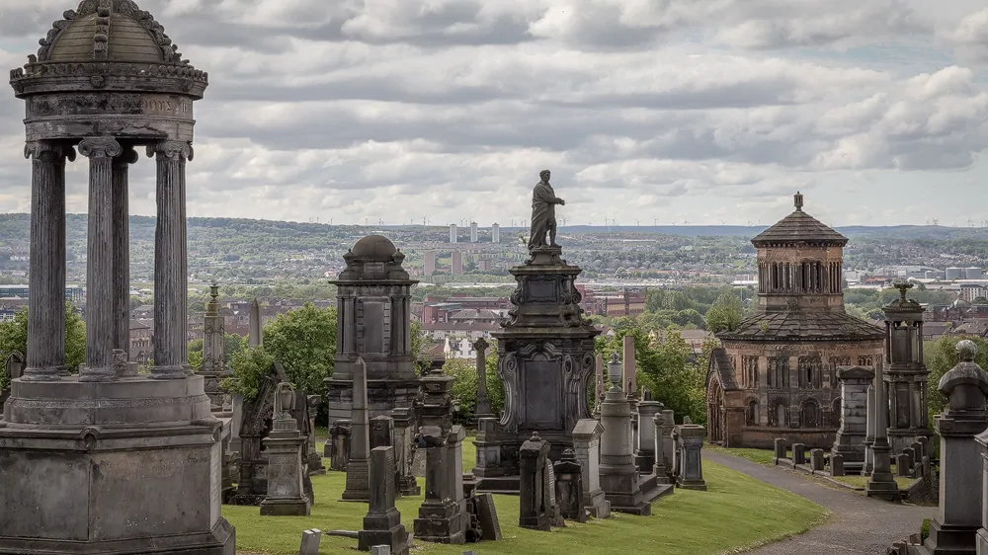

Following lunch there is an optional guided tour of the Glasgow Necropolis, where Cemetery & Sculpture Historian Gary Nisbet will take us on a guided tour of the resting places of individuals associated with science, technology, and medicine.
NB: The Necropolis is approximately a 10-minute walk from the Technology & Innovation Centre. Some parts of the paths within the Necropolis are uneven or uphill. Sensible shoes are recommended.

